Ex. No. : 03 Date: 23-02-2026
Register No.: 231701043 Name: Ragul M

Wireframing and Prototyping Using Figma
Aim
To design and prototype a Learning Hub Mobile Application using Figma that enables users to explore courses, access study materials, track their progress, participate in quizzes, and navigate different learning modules through an interactive and user-friendly mobile interface.

Procedure:
- Requirement Analysis
  - Identified the essential features required for the Learning Hub app:
a. Course category selection
b. Course details page
c. Video lessons and study materials
d. Progress tracking dashboard
e. Quiz and assessment section
f. Profile and back navigation
- Creating Frames in Figma
- Opened Figma and selected the iPhone 14 & 15 Pro Max frame size.
  - Designed multiple key screens:
a. Home / Course Categories Screen
b. Course Details Screen
c. Learning Module (Video/Content) Screen
d. Quiz Screen
e. Progress Dashboard Screen
- Wireframing
- Created low-fidelity wireframes using simple shapes like rectangles and placeholders for images and text.
- Organized content sections clearly, including course cards, navigation bar, and action buttons.
- Ensured proper spacing, alignment, and touch-friendly button sizes for better usability.
- High-Fidelity Design
- Applied a consistent color palette and modern UI theme suitable for an educational platform.
- Added rounded cards, icons, illustrations, and clear typography for better readability.
- Established strong visual hierarchy by highlighting important elements like “Start Learning,” “Continue,” and “Submit Quiz.”
- Maintained uniform spacing, consistent fonts, and cohesive design components across all screens.
- Prototyping
- Used the Prototype tab in Figma to add interactivity.
  - Configured interactions such as:
a. Course card → Navigate to Course Details Screen
b. Start Learning button → Navigate to Learning Module Screen
c. Take Quiz button → Navigate to Quiz Screen
d. Back button → Return to previous screen
- Added smooth transition animations and tested the flow using Present mode.
- Testing and Refinement
- Reviewed layout alignment and overall design consistency.
- Improved text readability, color contrast, and accessibility.
- Verified seamless navigation between screens to ensure a smooth user experience.

Output
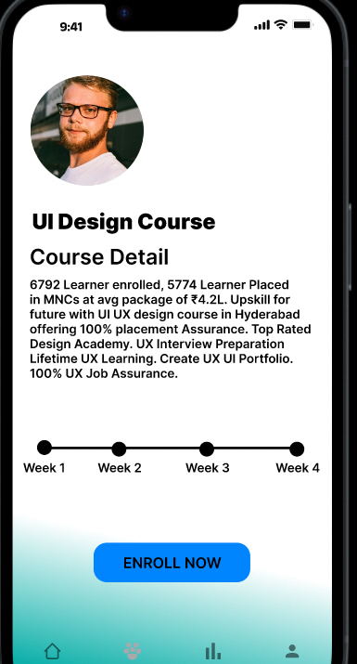
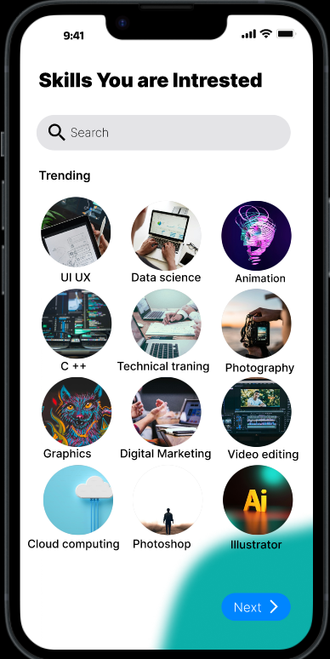
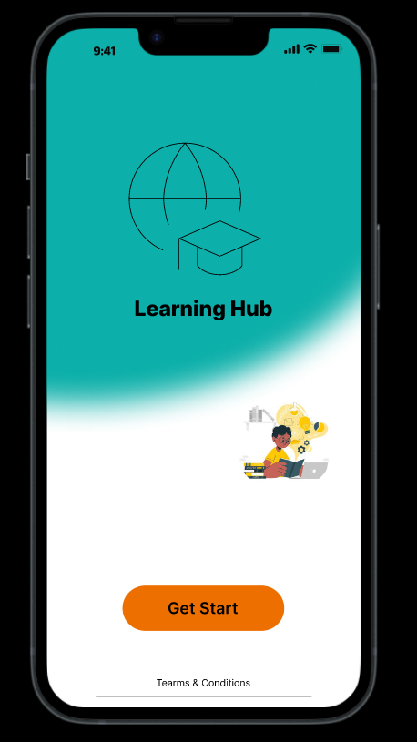

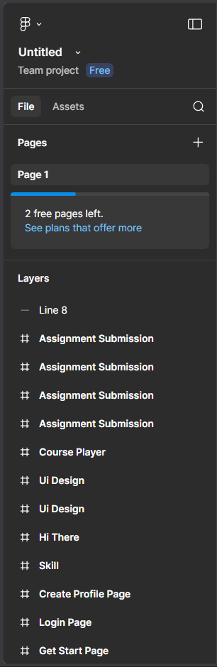
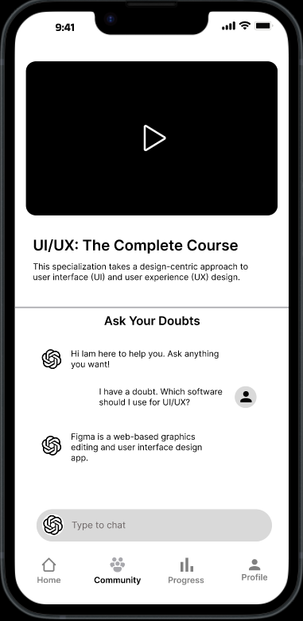

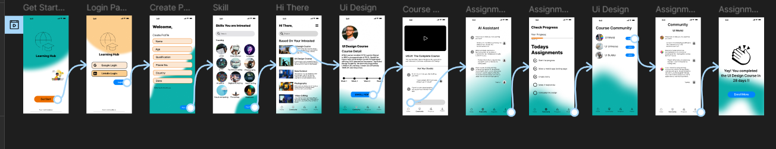

Result:
The TV Remote Mobile Application was successfully wireframed and prototyped using Figma. The application includes interactive screens for brand selection, remote control functions, and numeric input. The prototype demonstrates effective UI design principles, smooth navigation flow, and a user-friendly interface.

